[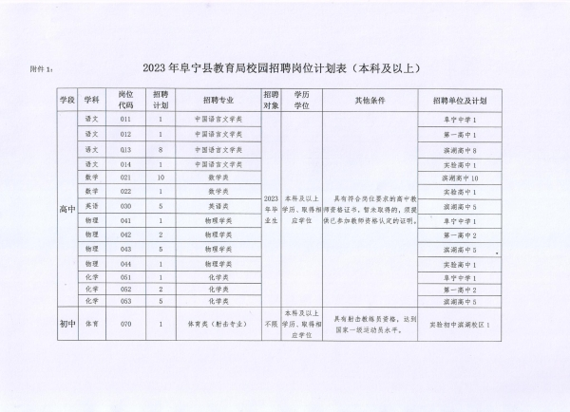](http://funing.yancheng.gov.cn/picture/0/4530863e1d9c4b66a74e2b270aadcd28.jpg)[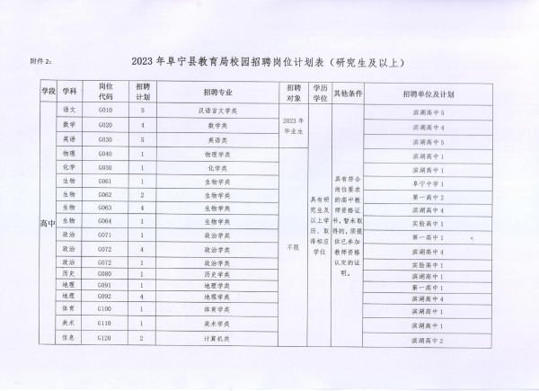](http://funing.yancheng.gov.cn/picture/0/cfe75c22c10d4423a155d70363aa4e3c.jpg)[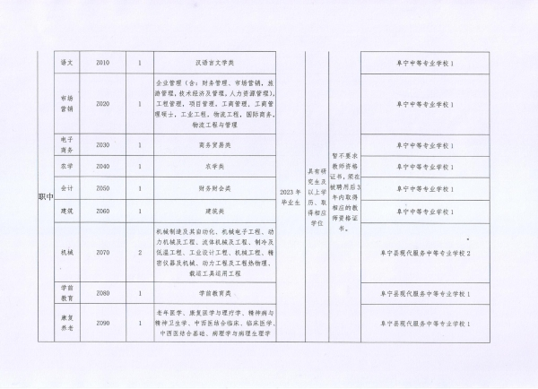](http://funing.yancheng.gov.cn/picture/0/47e3322668c94f8992ca5b676e210fc8.jpg)[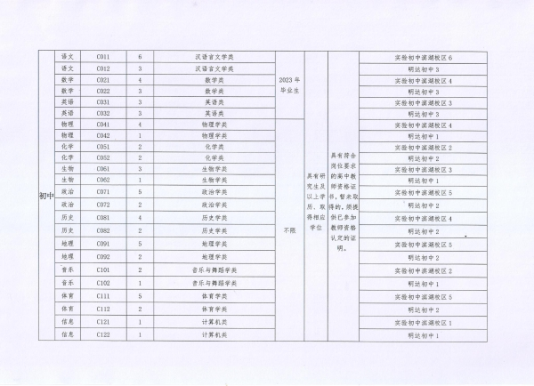](http://funing.yancheng.gov.cn/picture/0/17d58f6bc837448ca9cb19800545d7fb.jpg)[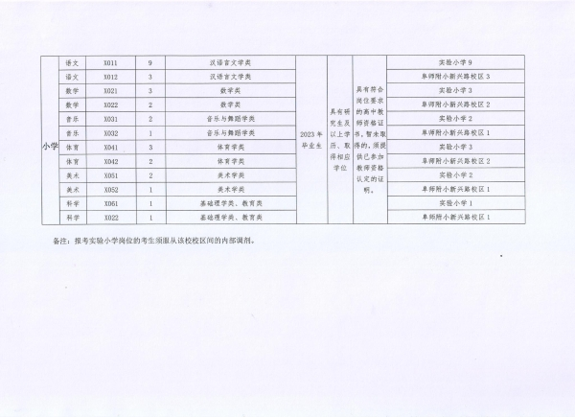](http://funing.yancheng.gov.cn/picture/0/c3cf72e508c94b738b66446cdc7e8029.jpg)

[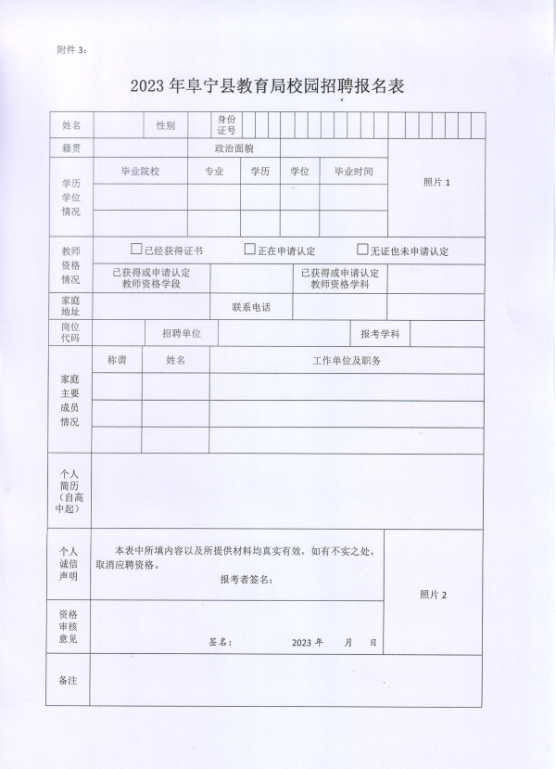](http://funing.yancheng.gov.cn/picture/0/4ca24e6775e14b77ae40d76ad1362a79.jpg)